Spatial Informatics Preliminary Report

Ansh Chablani

2022111031

Title—Optimal Trajectory Planning for a Mars Rover Using Spatial Data collected by Mars Orbiters

Description—This project aims to plan an optimal trajectory for a rover traveling between two selected sites. The rover trajectory is optimized by considering terrain difficulty, obstacles, and energy consumption constraints.

**Problem Definition and Final Objectives**

The problem is defined through the description and the objectives that follow in this report. There are several objectives that I aim to achieve. These are listed below.

The ones marked with (M) to the right are those which are completed with this mid-submission. These are documented in detail with this preliminary report and would be presented in the mid-submission presentation.

The ones marked with (F) are for the final submission and would be completed before the submission due date later this month.

There are also some items marked with (E) meaning extras. These are ones which I am excited to complete but may not be able to complete before the submission due to time constraints. I would be hopeful to complete them.

1. (M) Find and establish a suitable CRS for Mars. (CRS = Coordinate Reference System)
2. (M) Find necessary data and extract out useful information from them.
3. (M) Using a DTM of a particular region of Mars, find a suitable movement directions given a start point based on only the slope data.
4. (M) Using the movement directions and the slope data, establish a means of finding a least cost trajectory given a start point. This establishes a good base over which I can put more constraints.
5. (M) List down all the spatial methods used for the same.
6. (F) Process more data similar to the slope data to add more constraints to the path optimisation problem.
7. (F) Inculcate danger zones – deep craters, big rocks.
8. (F) Make local slope analysis (limit the rover to a maximum slope of 30 degrees and max rock encounter to 2 * diameter of the wheels)
9. (F) Streamline into a pipeline.
10. (E) Make a 3D surface visualiser to make the robot traverse it (like a game).

# **ASSUMPTIONS OR CRITERIA**

## **Assumptions on Landing Sites**

Criteria for landing sites include

1. low slope
2. minimal elevation changes
3. proximity to water ice deposits
4. scientific interest

Scientific interest refers to the proximity to important artifacts like ice deposits, important rocks and craters.

## **Assumptions on Rover Path**

The path the rover for which this trajectory is being computed is subject to the following assumptions:

The rover must avoid:

1. Steep slopes
2. Obstacles (rocks and craters)

It should minimise the energy consumption as well. This includes not only travelling on least cost paths but also maximizing solar exposure. Data about solar exposure is given by Mars Odyssey THEMIS (details in the section on data)

## **Assumptions on Precision**

The extent to which we are capable of estimating the trajectory precisely is dependent on the data publicly available from Mars missions. The ones with the highest resolution (like HiRISE) are limited to 1 meter at most places. This would be the limit when calculating the trajectory.

## **Assumptions on Extent and Extensibility**

While it is possible for calculating the trajectory of all of the places on Mars, the data for the entirety of the Martian surface is not available and hence given any two random points, we would be able to generate the trajectory only if all data is present. For example the data is usually cantered around specific areas of interest.

Here is an image, showing that the data is only available in parts to us:

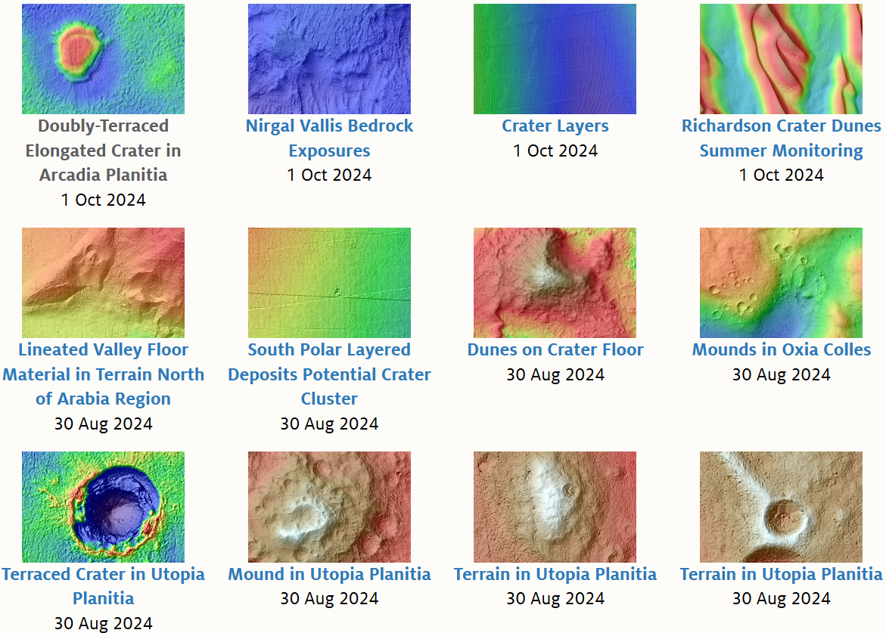

# **Data – SOURCE, CHARACTERISTICS**

In this section, I will describe the data I am using for the purpose of the project. I will also describe the source and characteristics of each type of data I am using.

## **MOLA (Mars Orbiter Laser Altimeter)**

**Source:** MOLA data was collected by NASA's Mars Global Surveyor, which orbited Mars from 1997 to 2006.

**Characteristics:**

1. **Purpose**: Provides highly accurate elevation and topography data for Mars, essential for understanding the planet's surface structure and geological features.
2. **Data Type**: Altimetric data, which measures the time it takes for a laser pulse to travel from the orbiter to the planet's surface and back. This creates a detailed digital elevation model (DEM).
3. **Resolution**: MOLA data has a vertical accuracy of about 1 meter and a spatial resolution of approximately 100 meters in low-lying regions, allowing scientists to visualize large-scale terrain features as well as smaller details.
4. **Applications**: Used extensively for topographical mapping, geological analysis, and to support landing site selection by identifying safe, level areas for Mars missions.

**Limitations**:

1. **Resolution Constraints**: Although detailed for large-scale mapping, MOLA’s resolution (100 meters per pixel) is too coarse for identifying small-scale features critical for landing site or rover navigation, such as boulders or fine terrain variations.
2. **Data Gaps**: MOLA provides limited data on steep terrains like cliffs and crater walls, where laser returns are either unreliable or missing due to the angle of incidence.

**Here is the MOLA dataset which I extracted and georeferenced from the official website at 4PPD: (Colorized Elevation Map)**

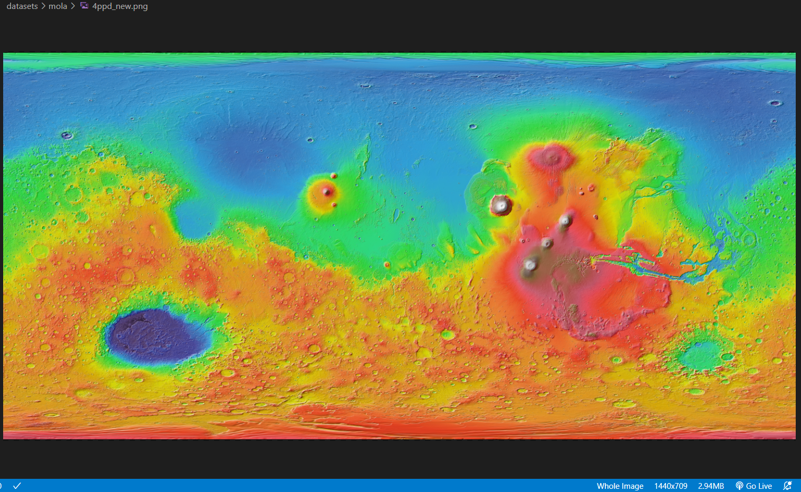

## **HiRISE (High-Resolution Imaging Science Experiment)**

**Source:** HiRISE is a camera on board NASA's Mars Reconnaissance Orbiter (MRO), which has been orbiting Mars since 2006.

**Characteristics**

1. **Purpose**: Captures extremely detailed surface imagery of Mars, allowing identification of surface features such as craters, rocks, and obstacles. It's especially valuable for landing site assessments and geological investigations.
2. **Data Type**: High-resolution optical images, including both grayscale and color imaging.
3. **Resolution**: HiRISE has a spatial resolution of up to 0.25–0.3 meters per pixel, one of the highest resolutions available for Mars imagery, providing detailed views of the surface and small features.

**Note**: I am using a resolution of 1 meter per pixel.

**Limitations**

1. **Limited Coverage**: HiRISE can only image a small portion of Mars at high resolution due to storage and transmission limitations, covering less than 3% of the planet's surface. This restricts its use to targeted areas of scientific interest.
2. **High Data Volume**: The high-resolution images generate massive data files, making it time-consuming to process and analyze, especially when generating 3D models from stereo images.

**This is an issue which I faced, and it was very time-taking to generate even small trajectories.**

1. **Lighting and Atmospheric Conditions**: Dust storms and seasonal lighting changes can reduce image quality, affecting visibility of specific features or areas during certain times of the Martian year.

This is the HiRISE data which I used (view of QGIS):

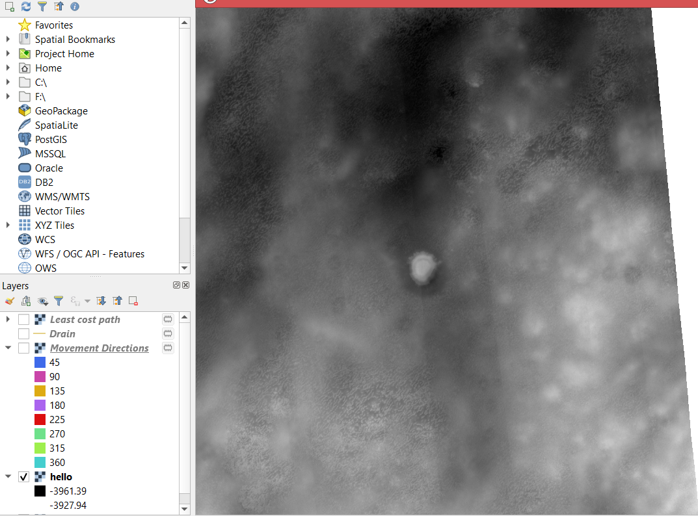

## **Mars Odyssey THEMIS (Thermal Emission Imaging System)**

**Source**: THEMIS is an instrument on NASA’s Mars Odyssey spacecraft, which has been orbiting Mars since 2001.

**Characteristics**:

1. **Purpose**: Provides temperature and solar exposure data for the Martian surface. This dataset is critical for understanding diurnal temperature cycles, thermal inertia, and surface composition.
2. **Data Type**: Multispectral infrared images and visible-light images, capturing temperature variations and solar energy absorption across the Martian surface.
3. **Resolution**: THEMIS infrared images have a spatial resolution of about 100 meters per pixel, while visible images achieve a resolution of up to 18 meters per pixel.
4. **Applications**: Supports energy-efficient pathfinding by helping mission planners understand temperature fluctuations, which impact rover energy management. THEMIS data also aids in identifying materials on the surface by their thermal properties, guiding geological studies and exploration strategies.

**Limitations**:

1. **Moderate Spatial Resolution**: The 100-meter resolution in infrared is sufficient for large features but lacks detail for smaller features and micro-topography. As a result, it may miss fine temperature variations in smaller features like individual rocks or small craters.
2. **Thermal Inertia Assumptions**: THEMIS data relies on thermal inertia to interpret surface materials, but variations in surface roughness, slope, and dust cover can lead to inaccuracies in identifying material types.

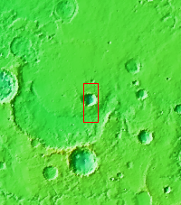

## **CRISM (Compact Reconnaissance Imaging Spectrometer for Mars)**

**Source:** Mars Reconnaissance Orbiter, operated by NASA, with data accessible via [JHU APL CRISM website](http://crism.jhuapl.edu/).

**Characteristics**:

* **Purpose**: Locates minerals and identifies regions of interest for signs of water or volcanic activity.
* **Resolution**: 18 meters per pixel in high-resolution mode, 200 meters per pixel in mapping mode.

**Limitations**:

* **Data Quality and Noise**: CRISM hyperspectral data is susceptible to noise, especially in low-light or dusty conditions. Some wavelength channels may contain noise, which complicates accurate mineral identification.
* **Limited Spatial Coverage and Seasonal Biases**: Due to limited data storage and transmission capacities, CRISM only maps portions of Mars, with priority given to high-interest areas. Its spectral imaging is not uniform across all seasons, so temporal analysis for seasonal changes may be challenging.

**Here is an image of the carbonate deposit as seen from CRISP.**

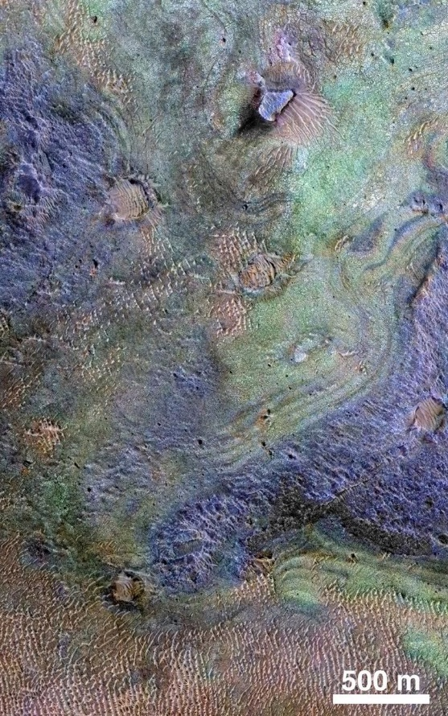

# **Spatial / Spatio-Temporal Methods used**

I have mostly used Spatial methods for the purpose of the mid-submission.

They are listed as follows:

* Raster Reprojection
* Georeferencing
* Cost Surface Analysis - Cumulative Cost Mapping
* Cost Surface Analysis - Movement Direction Mapping
* Spatial Extent Definition
* Least-Cost Path Analysis
* Segmentation

Here are these methods written in detail:

**1. File Format Conversion (GDAL)**

* **Method**: $gdal_translate$
* **Usage**: Converted the original $.img$ file from the HiRISE dataset to a .tiff format. This conversion ensures compatibility with QGIS and certain tools. It prepares the data for further analysis by making it accessible in different software environments.

1. **Georeferencing**

* **Method**: Georeferencing in GIS
* **Usage**: Assigned real-world geographic coordinates to the raster image, ensuring it aligns with a coordinate system ($MARS 2000$). This step is critical for spatial accuracy, allowing the image to be integrated with other spatial layers and enabling precise spatial analysis.

1. **Cumulative Cost Surface Calculation**

* **Method**: $r.walk.rast$ (from GRASS GIS toolbox in QGIS)
* **Usage**: Used this tool to generate a **cumulative cost surface**. This process calculates the accumulated "cost" of movement across the landscape from a starting point, considering the slope factor only (for now, will add more in final submission). The resulting raster represents the total cost of travel to each cell, which is vital for analyses that consider movement or accessibility across a region.

1. **Movement Direction Mapping**

* **Method**: $r.walk.rast$ (continued)
* **Usage**: Alongside the cost surface, $r.walk.rast$ also computes **movement directions**. This raster indicates the direction of travel from each cell to its least-cost neighbouring cell. It provides a flow direction map, which can be used to model movement, water flow, or other directional processes.

1. **Spatial Extent Specification**

* **Method**: GRASS region extent
* **Usage**: Defined the spatial extent (the area of interest) for the analysis by specifying a **GRASS region**. This step limits the analysis to a specific region of the raster, improving efficiency and focusing the study area on regions of relevance while reducing computational overhead on the entire dataset.

I did this because the HiRISE dataset for even a small region is huge, and it was theoretically taking many hours to calculate the entire least cost line.

1. **Least-Cost Path Analysis**

* **Method**: $r.drain$ (from GRASS GIS toolbox)
* **Usage**: Isolated a small region within the larger dataset and applied **least-cost path analysis** to identify the optimal route from a starting point to a target location. This tool traces the path that incurs the least cumulative cost, based on the previously calculated cost surface, which can represent the most efficient path for movement, resource transport, or ecological corridors.

1. **Map Segmentation**

* **Method**: Area segmentation (manual selection)
* **Usage**: Focused the analysis on a smaller segment of the raster by selecting a specific area of interest. Segmentation helps isolate regions, making the analysis more manageable and ensuring that the pathfinding and cost calculations are concentrated where they are most relevant.

**Initial Results**

## **MOLA dataset and problems with it**

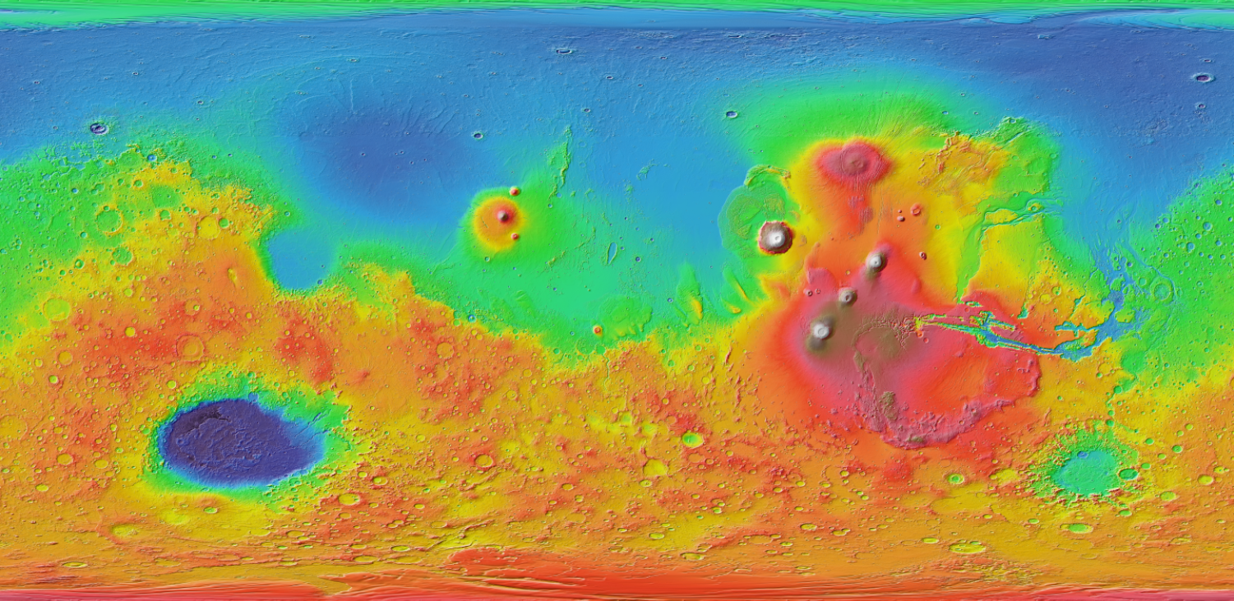

This is the mola dataset for the relief map is constructed.

This is good for getting a rough idea of the vertical elevation around a large enough area, highlighting important features. However, some calculations show that using this is not favourable for the planning of a trajectory for a mars rover.

MOLA dataset is available in PPD (= Pixels per Degree)

$$Circumference of Mars \left(C\right)=2πr$$

$$C=2π×3,396,000≈21,341,000 meters$$

$$Distance per Degree=\frac{C}{360}≈\frac{21341000}{360}$$

$$≈59216.67 metres$$

Converting PPD to Meters per Pixel

$$Metres per pixel=\frac{Distance per degree}{PPD}=\frac{59216.67}{n}$$

The highest resolution available is 512 PPD

$$Meters per pixel=\frac{59216.67}{512}≈115.7 metres per pixel$$

Adequate map for usage on home systems is 4PPD or 8PPD if we are considering entire map

$$Meters per pixel=\frac{59216.67}{4}≈14804 metres per pixel$$

We clearly see that we cannot use the MOLA dataset for precise trajectory calculations.

This is because even with the highest resolution of 512 PPD, we still have about 115.7 meters per pixels which is very large.

Also, for practical maps of 4PPD resolution, there is no way we can do any meaningful calculations for the trajectory estimation.

## **Switch to HiRISE dataset**

As shown in the calculations in the last section, we cannot use the MOLA dataset for the trajectory calculation. We have to instead use a High Resolution dataset. HiRISE comes into play here.

I extracted the [**Doubly-Terraced Elongated Crater in Arcadia Planitia**](https://www.uahirise.org/dtm/ESP_035651_2210) DTM from the HiRISE datasets.

In QGIS,

**PTO**

#### **Cumulative Cost Map**

**Legend**

#### **Movement Directions**

**Mosaic of movement directions**

**Legend**

**Least Cost Path within a limited region**

##### LINKS AND REFERENCES

1. GitHub Repo (Will be made public after final submission):

<https://github.com/anshium/spatial-informatics-project>

1. MOLA Dataset:

<https://www.mars.asu.edu/data/mola_color/>

1. HiRISE Dataset

<https://www.uahirise.org/dtm/>

1. THEMIS Dataset

<https://viewer.mars.asu.edu/viewer/themis>

1. CRISM Dataset

<http://crism.jhuapl.edu/data/publicData.php>

Computed using $r.drain$ for a small region for proof of concept. Larger regions require much more time. There are about 3250 pixels in this region.